Community Citizen Science

Project Title: Water Quality Monitoring in Río Indio, Morovis, Puerto Rico
Co-creators: Manuel Antonio García Berlingeri, José F. García Berlingeri, Sandra Berlingeri Santiago and Manuel García Vega
Of Community Concern: The community of Hoyo Frío has the concern that the waste water plant found along the banks of the Río Indio in the municipality of Morovis. The co-creators tested the hypothesis that the water quality downstream will be impacted by the treated water discharge when compared to the upstream water quality where there is no impact from the treated water discharge.
Methods: Three monitoring stations were established 50 m apart in the Río Indio (Photo 1), one at the waste water outfall site, one upstream, and one downstream. Water quality data was analyzed using standard kits for Dissolved Oxygen, Biochemical Oxygen Demand-BOD, Nitrate, pH, phosphate, temperature and turbidity, and collected monthly for a period of 6 months.
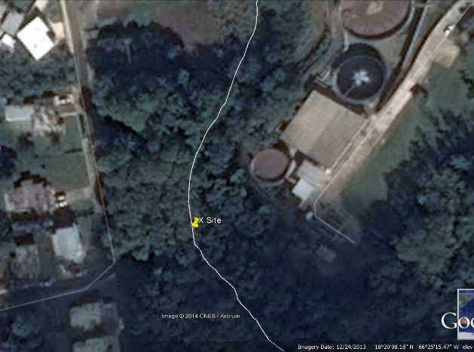
Upstream site (Upper)
Outfall site (X)
Downstream site (Lower)

Results: The co-creators found that there was no significant difference in the water quality between the upstream, downstream and outfall from the waste water plant (Table 1).
Table 1: water quality results of Río Indio, Morovis, Puerto Rico
Site | Date | Coliforms Total (CFU) | E. Coli (CFU) | Saturation (%) | Temperature (°C) | pH | Nitrate (ppm)
Upper | 2/15/2016 |  |  | 48 | 24 | 8 | 5
Point X | 2/15/2016 |  |  | 51 | 28 | 7 | 5
Lower | 2/15/2016 |  |  | 48 | 24 | 8 | 5
Upper | 3/29/2015 | 33 | 36 | 44 | 20 | 8 | 5
Point X | 3/29/2015 | 3 | 3 | 49 | 26 | 8 | 5
Lower | 3/29/2015 | 72 | 76 | 0 | 24 | 8 | 5
Upper | 4/19/2015 | 2434 | 1370 | 48 | 24 | 8 | 5
Point X | 4/19/2015 | 26 | 5 | 51 | 28 | 7 | 5
Lower | 4/19/2015 | 2424 | 62 | 48 | 24 | 8 | 5
Upper | 5/30/2015 | 94 | 87 | 48 | 24 | 8 | 20
Point X | 5/30/2015 | 25 | 9 | 0 | 26 | 7 | 5
Lower | 5/30/2015 | 130 | 30 | 48 | 24 | 8 | 5
Upper | 6/20/2015 | 9 | 25 | 48 | 26 | 8 | 5
Point X | 6/20/2015 | 87 | 94 | 50 | 30 | 7 | 5
Lower | 6/20/2015 | 30 | 110 | 49 | 26 | 8 | 5

Conclusions: Citizens’ concern been diminished because of the results of the monitoring.
Broader Impacts: The results of the project were presented at Citizen Science Fair “Explora el Norte” where close to 1,500 citizens participated. They also presented their findings at a community activity in the neighboring municipality of Ciales.

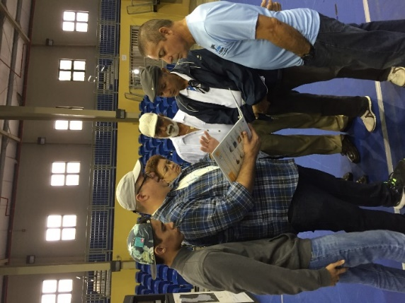
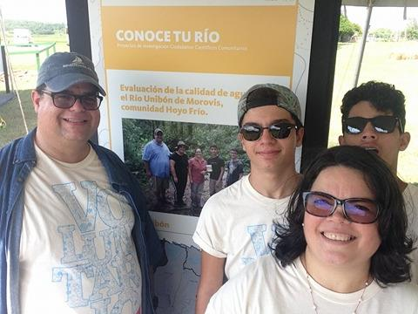

Co-creators during the Citizen Science Fair “Explora tu Norte” and in the community activity in Ciales, Puerto Rico.

