Community Citizen Science

Project Title: Study of coastal erosion in high impact tourist beaches
Co-creator: Jean Carlos Colón Bergollo
Of Community Concern: The municipality of Culebra is a smaller island that lies east of Puerto Rico. It is famous for its white sand beaches. In recent years with high storm surges coastal erosions has been occurring.
Methods: Jean Carlos adopted the scientific methods used by his mentor Dr. Barreto in the citizen science project in Río Grande of Manatí. Measurements of beach profile and sediments were taken biweekly for 6 months in two beaches (Flamenco and Tamarindo) in Culebra (Fig 1).
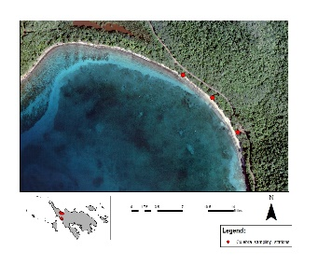
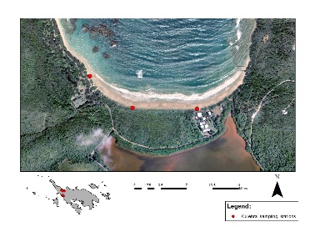
Figure 1. Location of Study Area in Culebra, Puerto Rico, left Flamenco Beach and right Tamarindo.

Beach profile monitoring was conducted using a Leica Jogger 32 and a CTS Berger tripod in three stations for each beach system. The absolute location of each station was marked by GPS in order to maintain a precise measurement. In addition, beach width measurements were taken at sites using an Open reel tape measure to evaluate changes in shoreline.
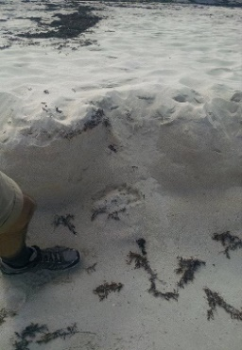
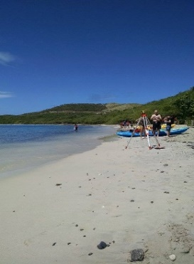
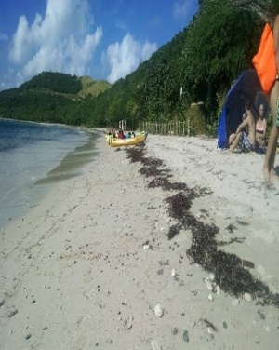
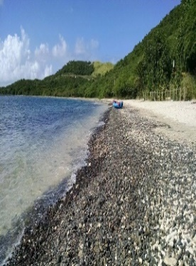
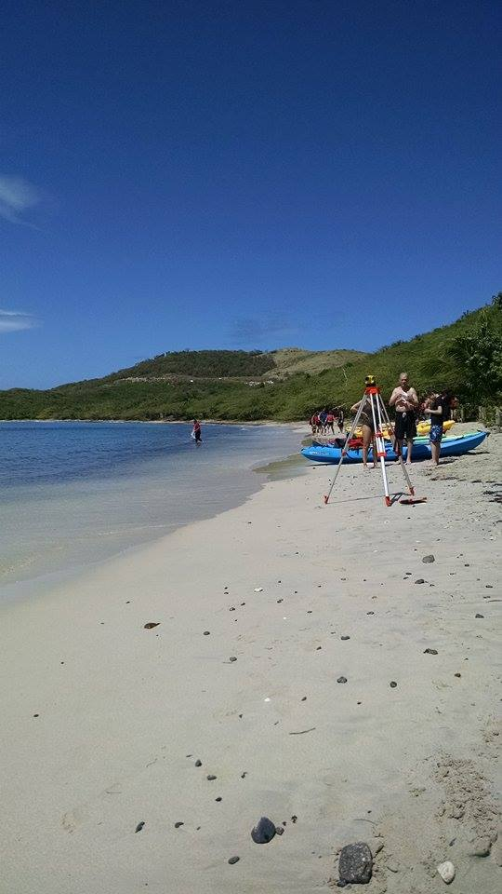
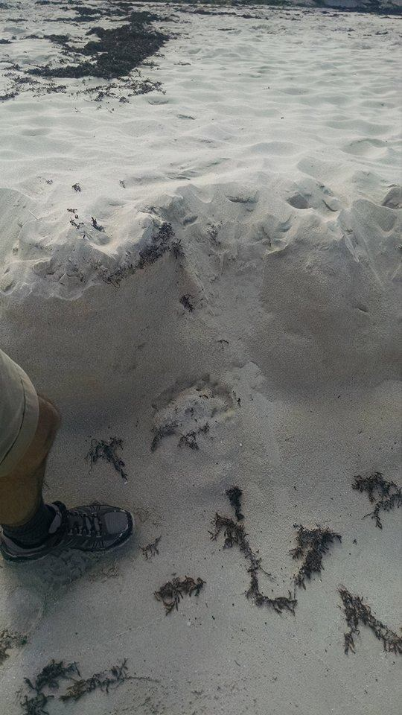

- Tamarindo 2) Flamenco
Photo 1: Major morphological changes observed at study area. 1). Grain size distribution for Tamarindo and 2) beach scarp at Flamenco.
Results: A negatively skewed population can be seen due to the tail of excess coarse particles. Bimodal distribution dominates most stations for Flamenco.

Figure 2. Frequency curves for all months and stations at Tamarindo Beach.
A negatively skewed population can be seen due to the tail of excess coarse particles. Multi-modal distribution is seen in some station at Tamarindo.
Figure 3. Frequency curves for all months and stations at Flamenco Beach.
Conclusions: Minor beach profile changes were identified at Flamenco Beach especially on the back beach (berm) area. However, major variations were found on the swash zone for stations 2 & 3 during December (2014) and February (2015) months (erosion). Minor beach profiles changes were also identified at Tamarindo Beach except for station 3 where beach width decreased during November (2014) and February (2015). Reduction of beach width may have related with the occurrence of swells on the area.
Broader Impacts: During this co-creator project, Jean Carlos contributed 95.5 volunteer hours and several volunteers from the local community and the University of Puerto Rico, was involved in data collection and analysis. The co-creator was first author to an oral presentation at the Annual Convention of the American Association of Geographers (AAG) 21-25 April 2015, Chicago, Illinois.

