Community Citizen Science

Project Title: Study of avifauna along the Río Grande de Manatí watershed, Puerto Rico
Co-creator: Ricardo Rodríguez Vélez*, a chemist from Florida, Puerto Rico
Community Concern: The Escalera Cave is frequently visited by local community members, however, there is no knowledge about the ecological value of the area. This father-daughter team educated the community through the creation of posters and delivery of oral presentations within the municipality.
Methods: bird surveys were carried out along 3 routes within the Río Grande Manatí Watershed, during a 24-month period, with mentor José Salguero Faría. Escalera Cave I and II were of interest to the co-creators who worked on carrying out bird surveys within forested and grassland areas.
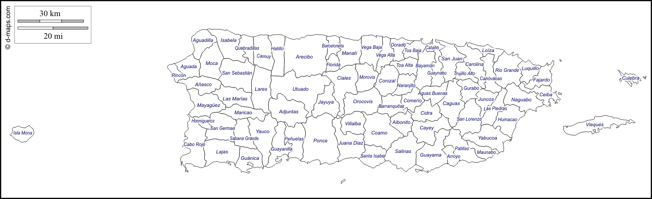
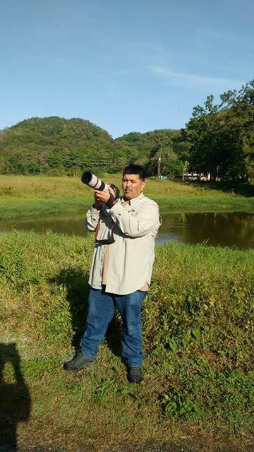
Figure 1: a) Black dot indicates the location of the Escalera Cave in the municipality of Florida, PR.
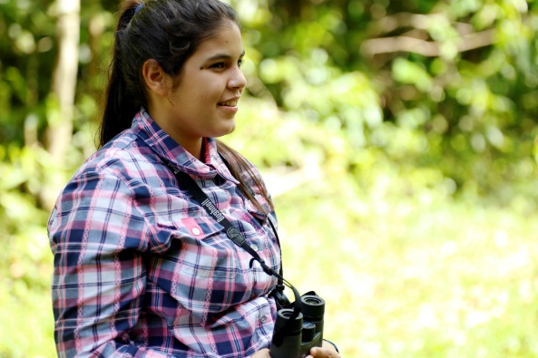

Ricardo and Laura within the different habitats found at Escalera Caves

Results: They found that Escalera I had 66 bird species while Escalera II had 30 bird species (Fig. 1).

Figure 1: Species accumulate curve at Escalera I and II, Puerto Rico

Conclusions: They found that birds have specific behavioral patterns depending on the time of day. They observed that birds were more active in the morning, rested during midday and regained activity levels in the late afternoon. Furthermore, they observed birds nesting throughout different periods of the year.
Broader Impacts: The co-creators contributed 154.32 volunteer hours to the project including fieldwork and educational talks in their community. They presented their results along with their mentor at the 20th International Meeting of Bird Caribbean in New Kingston, Jamaica, and submitted a paper to the Caribbean Ornithology Journal in March 2017. The father and daughter team have visited other areas in Puerto Rico for bird watching and Laura has decided to study science to eventually become a doctor.

*Laura C. Rodríguez Rodríguez is the 16-year-old daughter who assisted her father in this community science project.

