Community Citizen Science

Project Title: Documenting the abundance of shrimp to create conscience about water quality in the Río Bauta Abajo and Toro Negro
Co-creator: Luis Daniel Rivera Collazo, community member from Orocovis Municipality.
Of Community Concern: The study site is near the recreational area of the Department of Natural and Environmental Resources in Orocovis that receives numerous visitors annually, especially during the summer months. No prior studies have been conducted to determine shrimp diversity in the recreational area.
Methods: The Río Bauta Abajo, at an altitude of 118 m above sea level, is in Orocovis, Puerto Rico. It is a third order river and enters the main river of Río Grande of Manatí. The monthly sampling consisted of capturing shrimps and crabs with a net, using two persons per net during a period of 30 minutes in each habitat for two habitats, riffles, and vegetation or border. The shrimps captured were placed in a bucket for a lapse of 30 minutes. Shrimps were identified to species. Project sampling period was from July 2015 until January 2016.
Results: Four of the nine shrimp species were collected during the sampling period: Atya lanipes, Atya scabra, Atya innocuous and Xiphocaris elongata. They also found the only freshwater crab species Epilobocera sinuatifrons found in Puerto Rico (Fig. 1). The shift in species diversity was significantly through time, with higher density of X. elongata during the rainy months (Aug-Oct).

Figure 1: Diversity of species collected during sampling period from July 2015 to January 2016.
A total of 86 participants were involved in data collection until October 2015 (Table 1). These included adults and children under 18 of age.
Table 1: Distribution of participants impacted by this community science project
Month | Number of adults | Number of children | Total
July | 10 | 7 | 17
August | 10 | 7 | 17
September | 22 | 14 | 36
October | 10 | 6 | 16

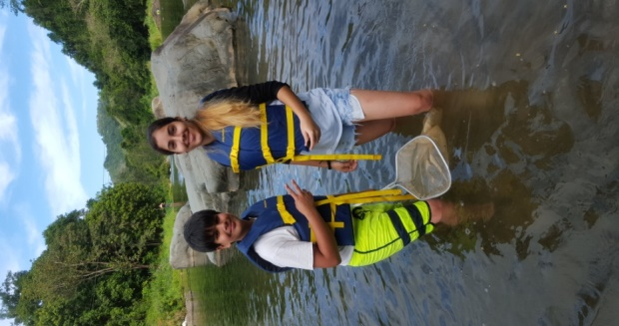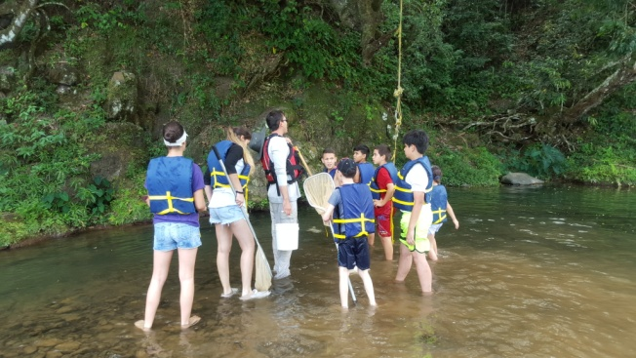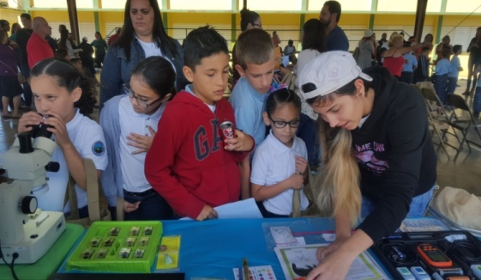
Conclusions: The species most tolerant to changes in the physio-chemical characteristics of the river were most abundant in months when storm runoff is highest.
Broader Impacts: During this project, the co-creator contributed 139 volunteer hours, working with the local community in data collection and analysis. The co-creator co-authored with scientist Rodríguez-Fourquet, Concepción a poster entitled: Río Bauta Abajo, Orocovis, Puerto Rico Monitoring: Citizen Science in Action at the American Geophysical Union Fall Meeting at San Francisco, 14-18 December 2015.

