Community Citizen Science

Project Title: Discovering the natural history of my community through archaeology
Co-creator: Karen Noemí López Nieves, university student from Loíza, Puerto Rico
Of Community Concern: The María de la Cruz Cave in Loíza is a hidden treasure that only locals visit; Karen documented the archaeological history of the cave using techniques learned with her mentor Dr. Isabel Rivera.
Methods: Fieldwork was conducted from July 2013 to May 2014 with the assistance of other co-creators in the project and her school teacher. Petroglyphs inside the cave were documented by drawing to be later interpreted.
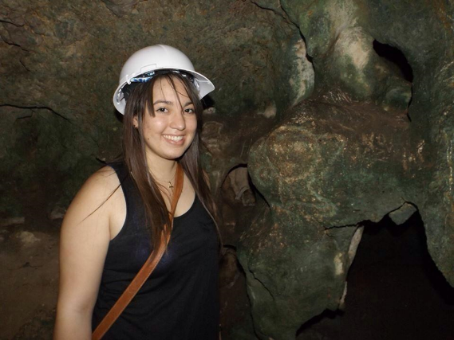
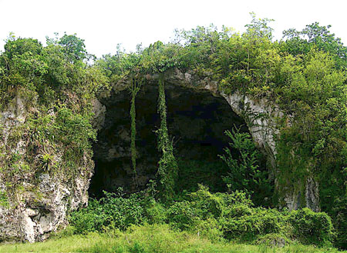
Photo 2: Entrance to the María de la Cruz Cave

Photo 2: Karen finding petroglyphs
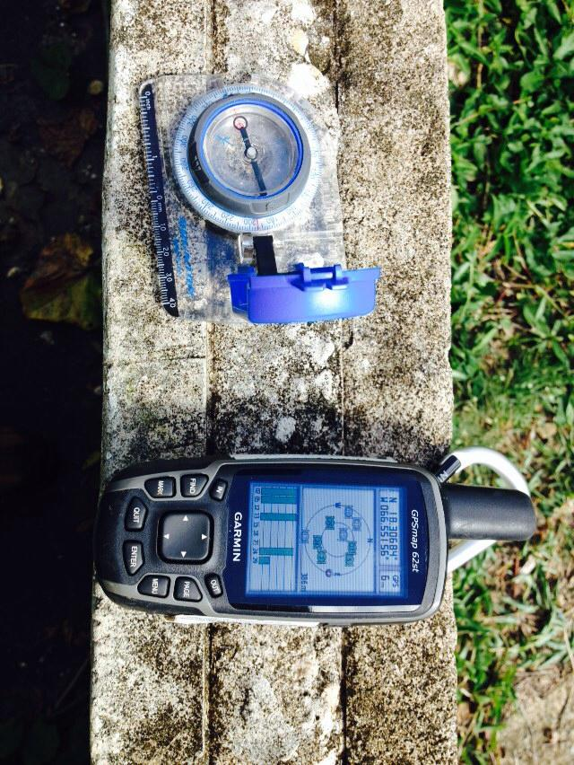

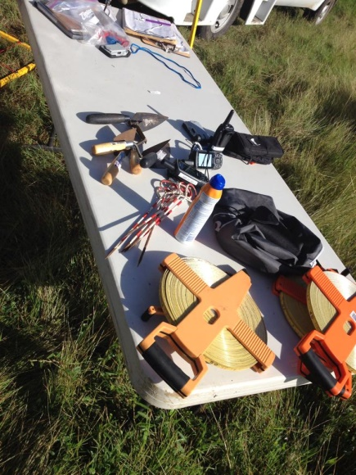

Photo 3 & 4: Learning to use various equipment in archaeological field studies
Results: Six petroglyphs were found in the cave (Photo 5). They were identified as early infant swaddle types, which represents the beginning of a local pteroglyph style which is associated with Taíno culture.
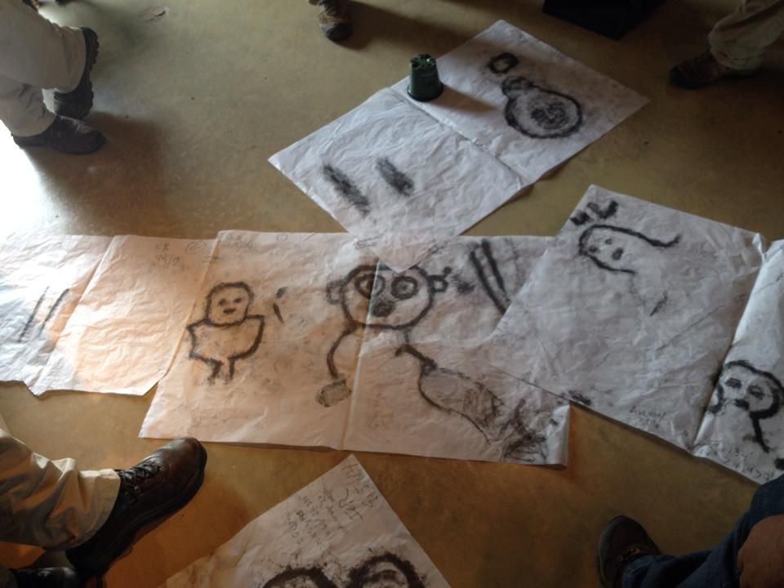

Conclusions: The María de la Cruz Cave is important to Puerto Rico’s cultural heritage. It is important for the conservation of caves.
“After reflecting about my research experience at the Hacienda la Esperanza in Manatí, I understood that archaeology was latent within me”. Karen López
Broader Impacts: This co-creator developed a clear understanding of archaeology and its value for the culture of Puerto Rico. It was during her participation in this project that she decided to apply to University of Puerto Rico for a Bachelor's degree in Anthropology- Archaeology. She is currently accepted in the program.

