Community Citizen Science

Project Title: Comparative study of beach morphology (beach width, grain size, and composition) in two beach systems in Puerto Rico

Co-creator: Gladys Valentín González, undergraduate student at the Department of Geography, University of Puerto Rico, Río Piedras Campus
Community Concern: Provide scientific information to fishermen and local businesses on the connection between river discharge and beach morphology as it affects access to fishing sites and tourism.
Methods: An evaluation of beach morphological changes in La Boca and Boquilla beaches adjacent to two main river systems in Puerto Rico. The Boquilla Beach drains the River Añasco watershed, and is located on the west coast in the municipality of Mayaguez; while the La Boca beach drains the Río Grande de Manatí in the municipality of Barceloneta. Geomorphological data (beach sediments and beach width) was collected monthly for four months from four permanent stations at each beach. Beach sediment samples were collected in the back beach and swash zone, then analyzed using Folk sieving analysis. Sediment composition was determined using weight differences between terrigenous and biogenic. River discharge data was extracted from Caribbean Observatory Stations.
Results: Opposing results were found at the two study sites for river discharge and beach width. Beach width at Boquilla beach increased with river discharge while beach width decreased with river discharge at La Boca. On both beaches terrigenous sediments increased with river discharge with larger grain size and a negative relationship was found between wave height and beach width. Beach width changes were identified during the occurrence of low pressure system such as cold front events.
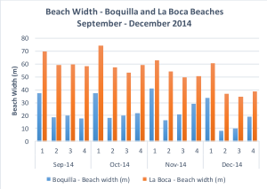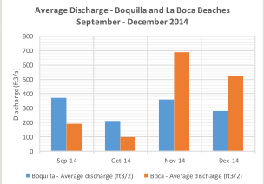
(a) (b)
Figure 1: Beach width and river discahrge temporal dynamics for two study sites Boquilla and la Boca beaches in Puerto Rico from September 2014-December 2014.
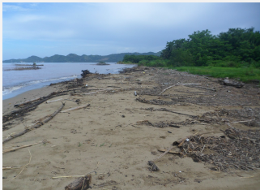 (a) 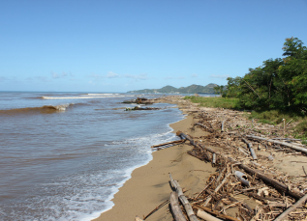 (b)
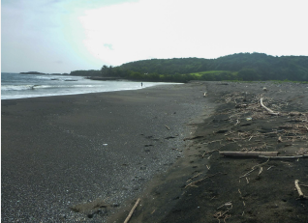 (c) 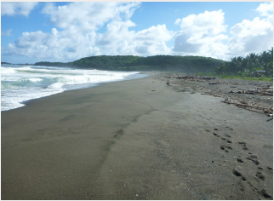 (d)
Photographs of beach changes at Boquilla Beach a) September 2014 b) December 2014 and at La Boca c) September 214 and d) December 2014

Conclusions: River discharge is an important source of beach sediments for both beaches. Possibly, the difference in geology and geographic position impacts beach width in the Atlantic coast of Puerto Rico.
Broader Impacts: During this project the co-creator contributed 265.25 volunteer hours, and recruited a number of volunteers from the local community and the University of Puerto Rico, who were involved in data collection and analysis. The co-creator was first author to a poster presentation at the Annual Convention of the American Association of Geographers (AAG) 21-25 April 2015.

